- 4 Queen Problem Output:


- Ecludian algorithm to demonstrate gcd:
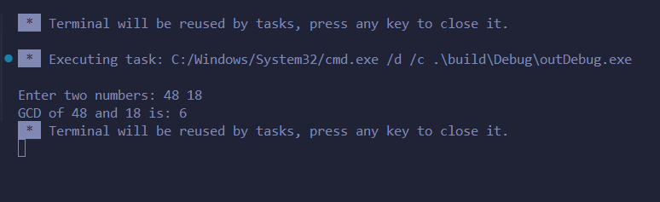

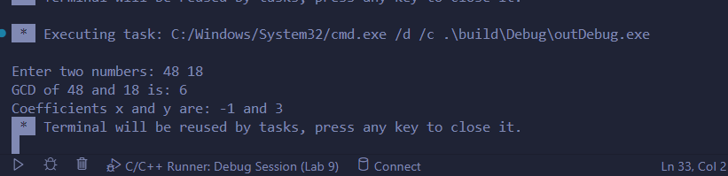
- Extended Ecludian to demonstrate gcd:

- Chinese Remainder theorm:
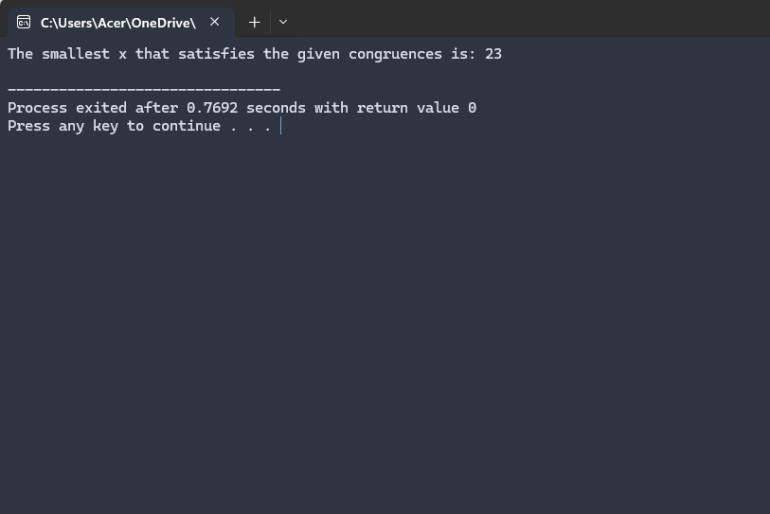

- Miller Robin Output:

